**CS551 ADVANCED SOFTWARE ENGINEERING**

**PROJECT- SECOND INCREMENT- GROUP 4**

**OCCASIONS ON THE GO**

**Team Members:**

Prathyusha Dinne (16161128)

Anudeep Vattipalli (16158489)

Poojitha Mittapally(16157740)

**Introduction:**

Planning an event is very simple and is on high demand. To plan an event, you need to select every vendor, login to their websites and order the required services. Also, it will be difficult to adapt to different patterns and designs as each vendor has their own in built design. To avoid these problems, our project acts as a single stop where in user can find different vendors in one place with a common user interface (UI). This project provides feasibility to order services both through mobile and web applications. In this application, both users and vendors can take advantage as user will be provided with best deals and vendor can attract customers by giving offers.

**Implementation Status Report:**

**Work Completed till 2nd Increment:**

In second increment, along with the 1st increment development we designed web services for search, categories, menu listing. We have also created web services for the registration and login of vendor and user. Below pages were developed in second increment.

* Profile page for all vendors (Photography, Venue, Catering and Theme) .
* Display page for all vendors
* Menus and Services page for all vendors
* Menus and Services edit pages for all vendors.
* Profile editing page for all vendors.
* Developed web service to retrieve login information and to register.
* Developed web service to retrieve menu items of all vendors.
* Profile editing pages for the users
* Vendors place will be shown on Google map
* User can add the items to the shopping cart
* User can view and remove the items from shopping cart

**Web Services:**

The web services which we developed were:

1. Login web service
2. Vendor menus
3. Item find

Login web services have the following methods:

1. User and vendor Login check
2. User profile update
3. Vendor profile update
4. Vendor Profile retrieval
5. User Profile retrieval
6. User registration
7. Vendor registration

Vendor Menu and Item find web service has the following methods:

1. Adding Menu items (for Catering and Theme Vendors )
2. Editing Menu items
3. Retrieval of menu items
4. Adding services for vendors (for Photography and Venue Vendors)
5. Editing services for vendors

**Item Menus Table:**

This table consists of all the items and their details for each and every vendor. All details like item name and description will be saved along with the item type and item price.

Queries Used for this table were:

a) Insert into items_menus values( item_name , item_price, item_desc, item_type, vendor_name)

b) Update into items_menus values( item_name, item_price, item_type, item_desc where vendor_name =”xxx”)

c) Select * from item_menus where vendor_name=”xxx”

**Implementation of Services :**

Below services developed as part of this increment is:

1. Google Map services
2. Shopping Cart services

As part of user interface, we have implemented sliding of images on the web pages for effective web page view.

**Screenshots of Web Application:**

**Home Page:**

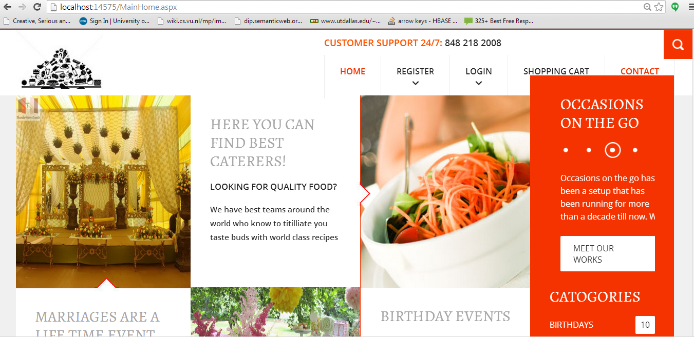

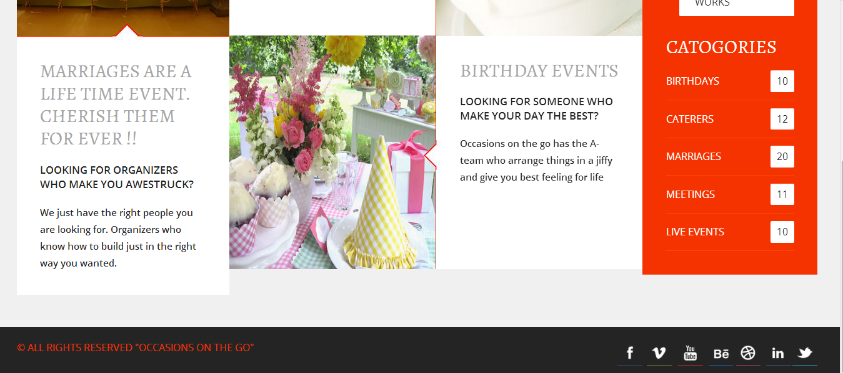

**Login Page:**

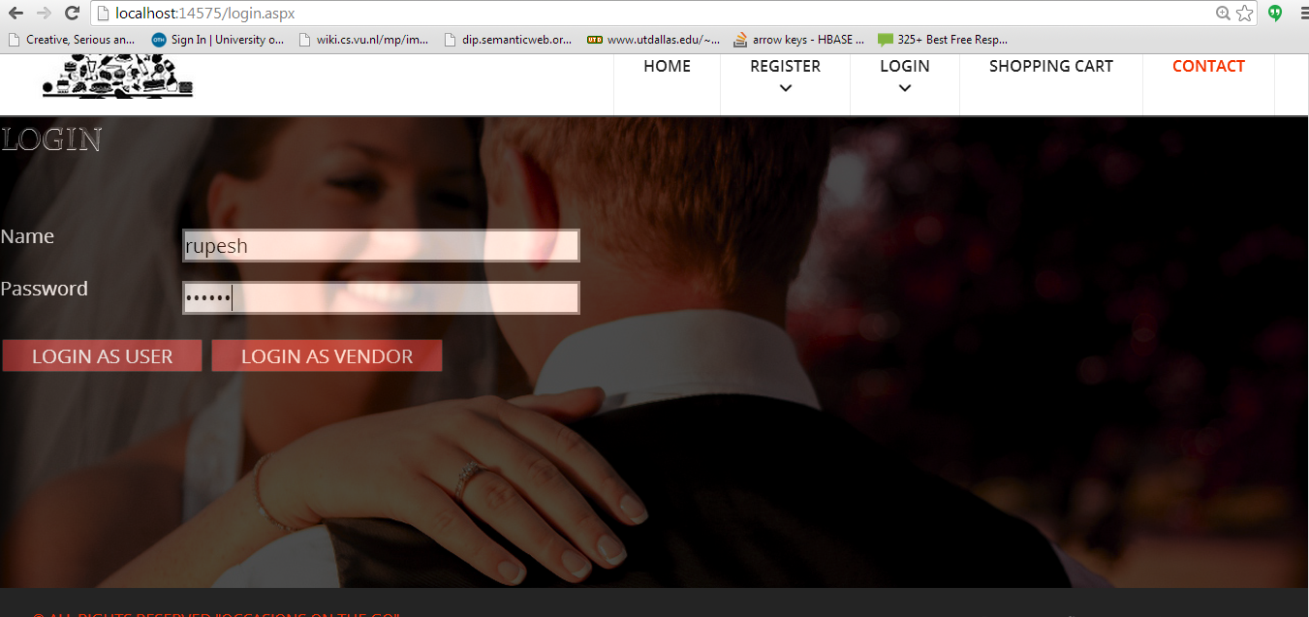

**User Profile:** After login the user is redirected to below screen with options of editing his user details and also to choose among list of available services as below.

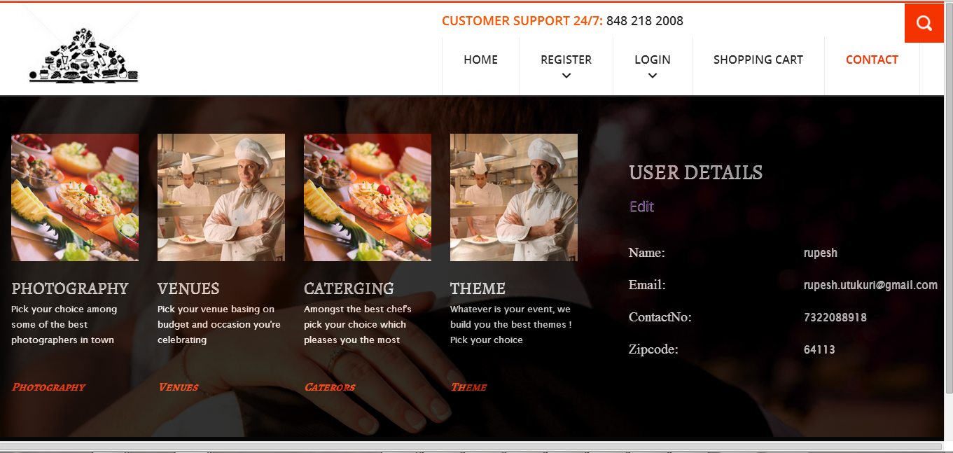

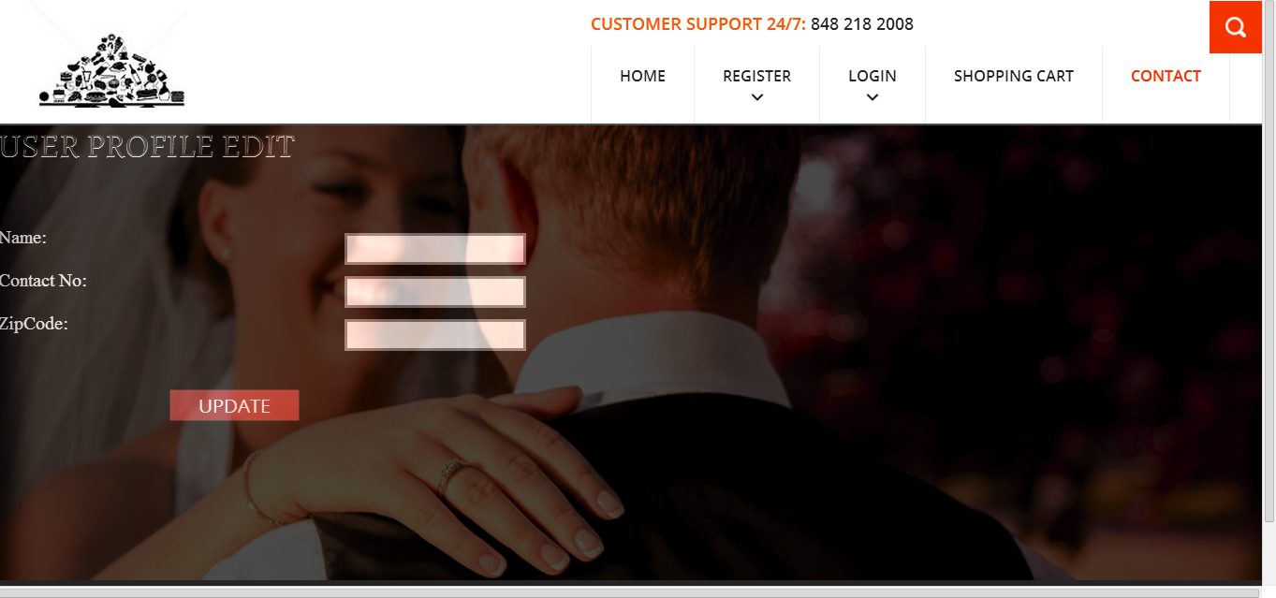

**Vendor Display:** Below screen shows vendor details of different vendors to user, where one can choose different options available.

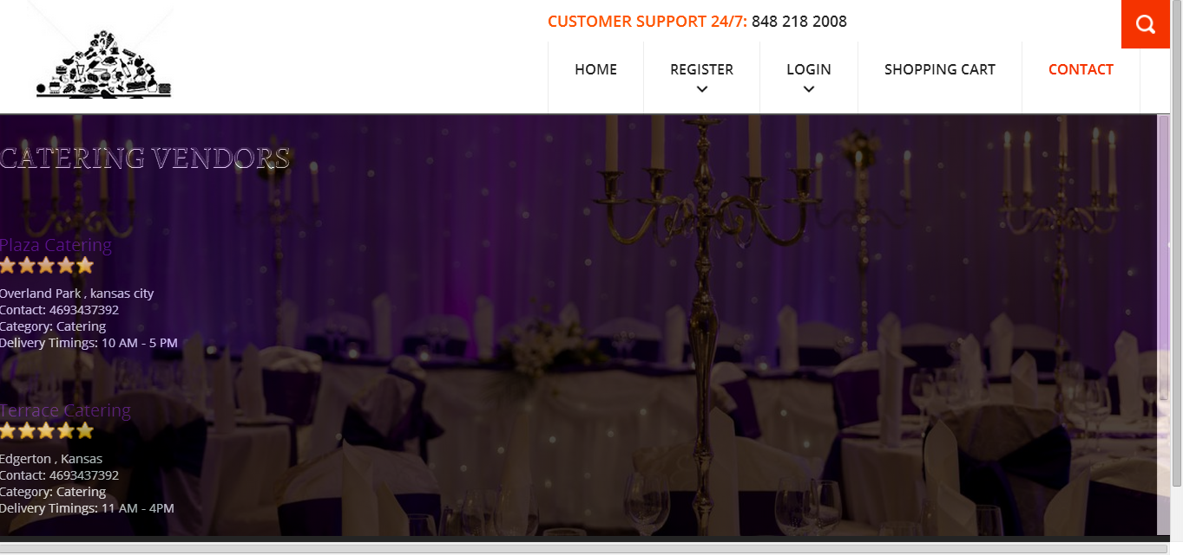

**Vendor single:** Below screens show individual vendor details, contact information and location through google map services.

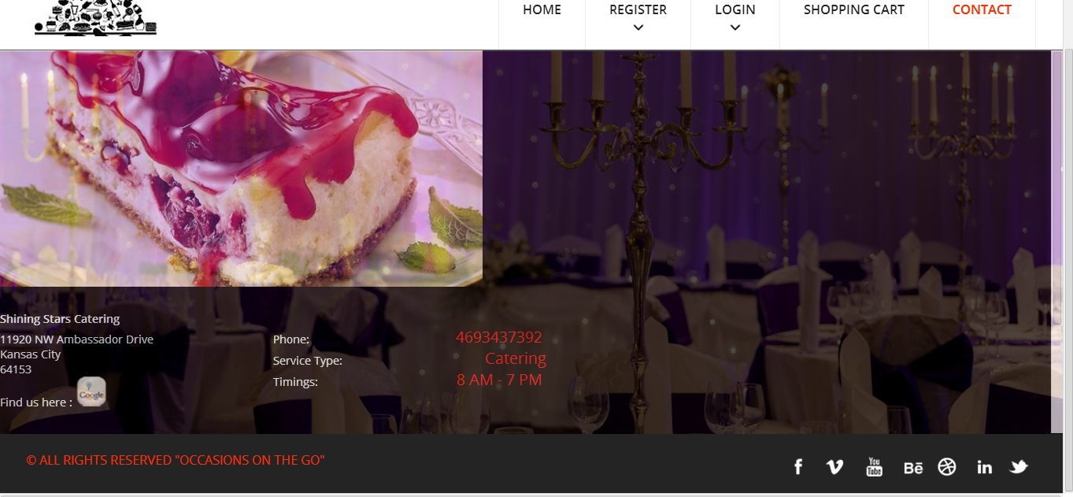

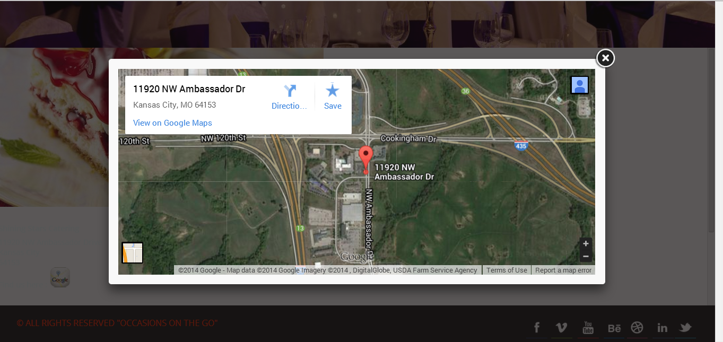

**Menu Display:** Below screen consists of different eatable items and prices with option of adding them to cart.

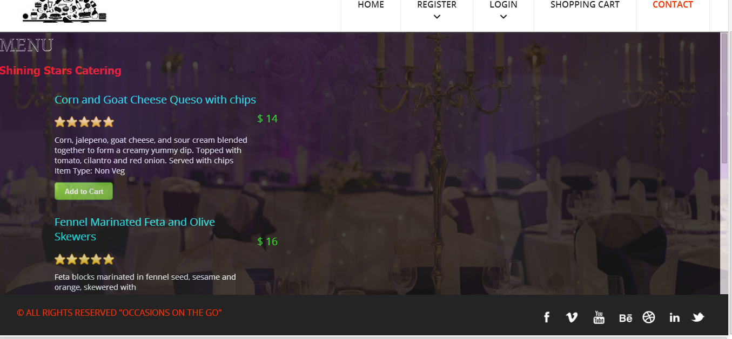

**Shopping cart:** All the items added to cart are displayed in the shopping cart page with sub total of all the items and check out option.

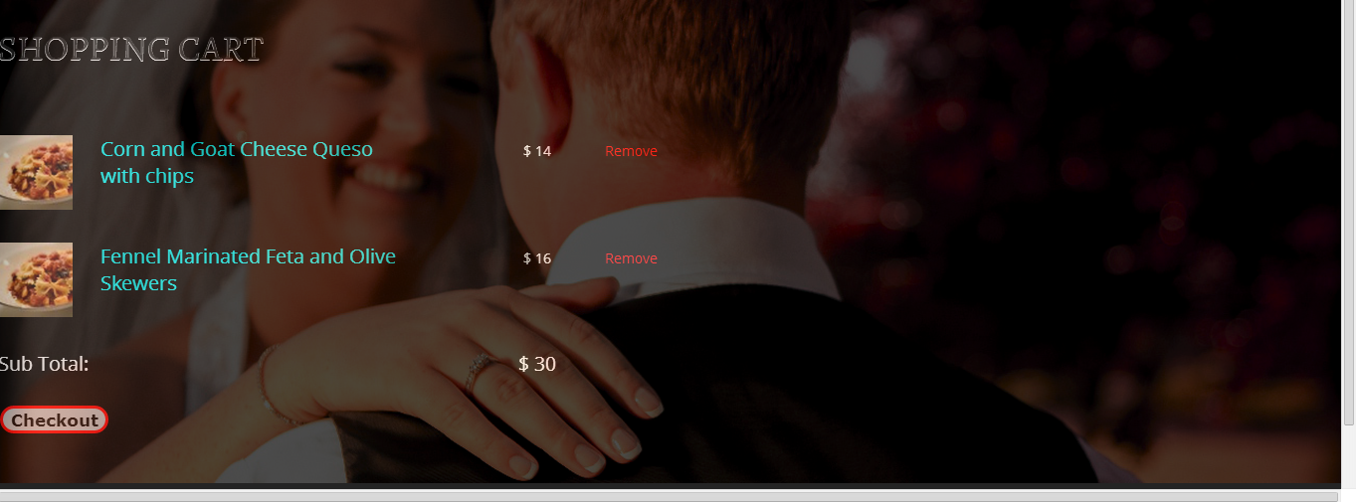

**Vendor Display:** Photography services



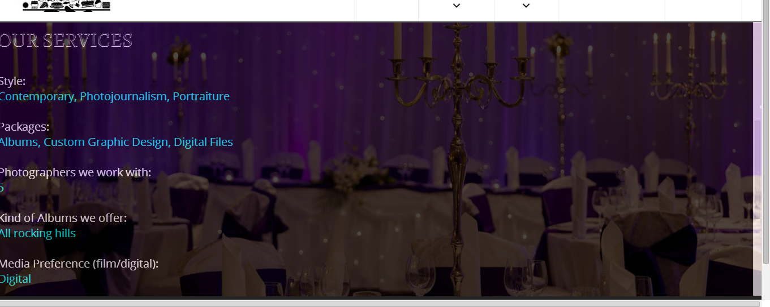

**Register As Vendor:** Vendor login page different from customer login page.

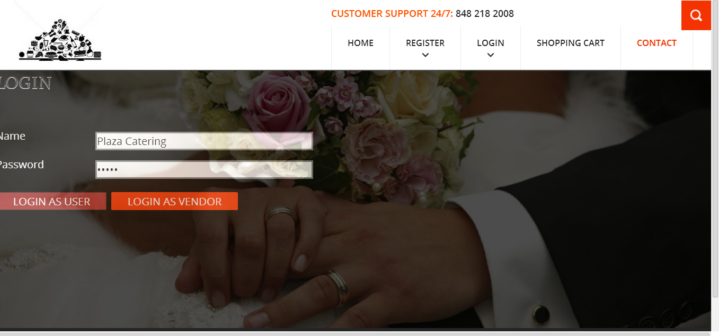

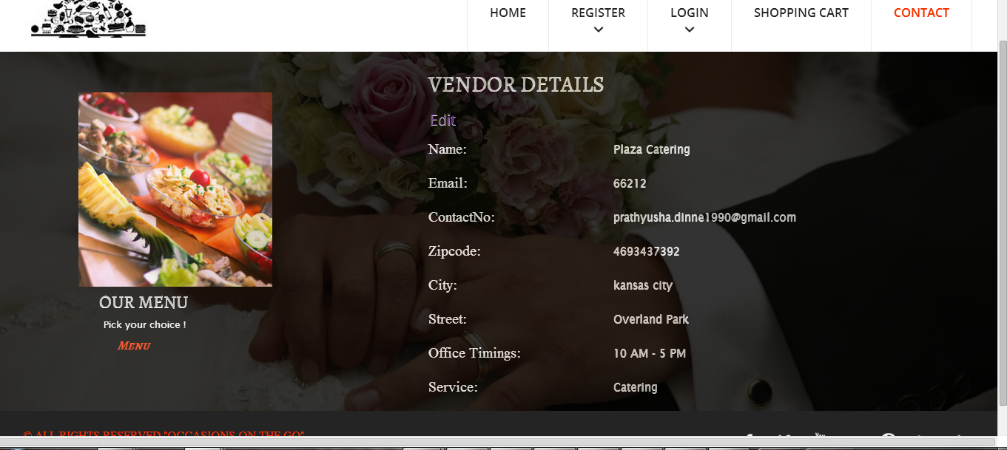

**Menu Display:** Vendor details are displayed in the below screen.

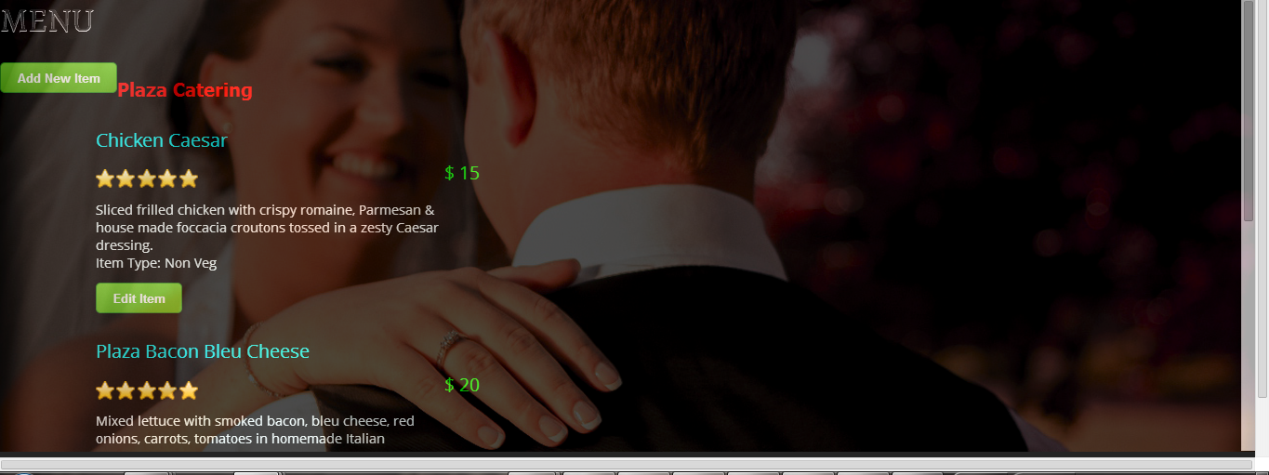

**Photo_ Menu:**

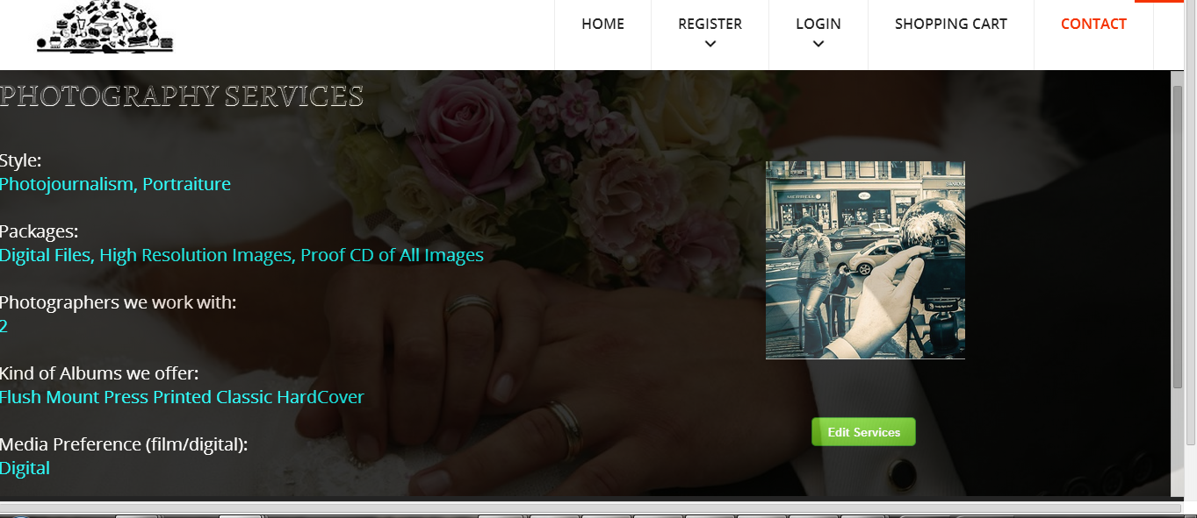

**Database tables:**

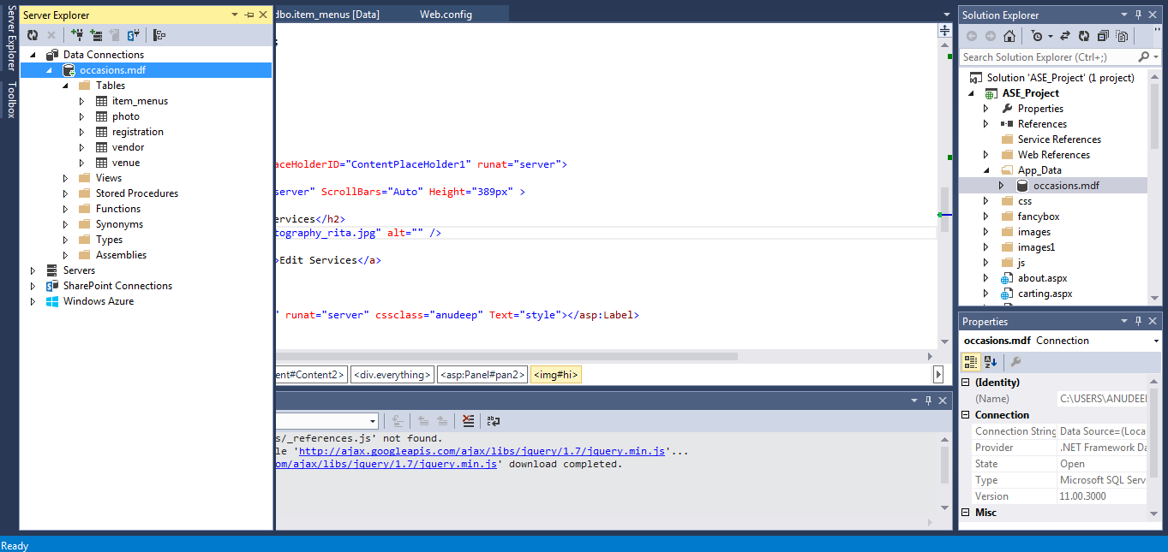

**Android App Screenshots:**

**Login Page:**

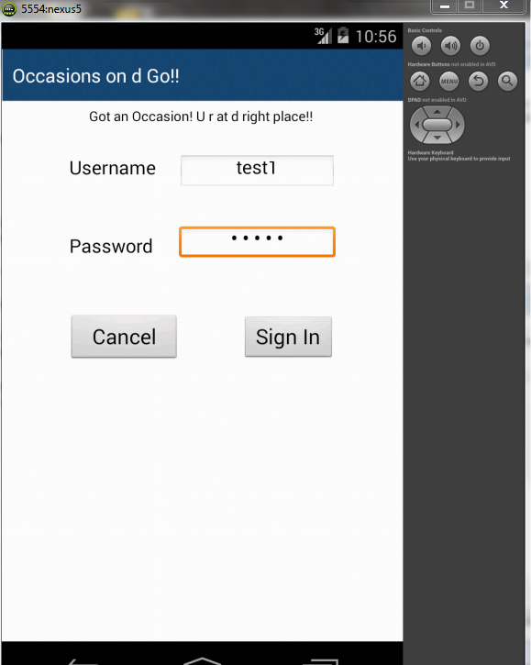

**Home Screen:**

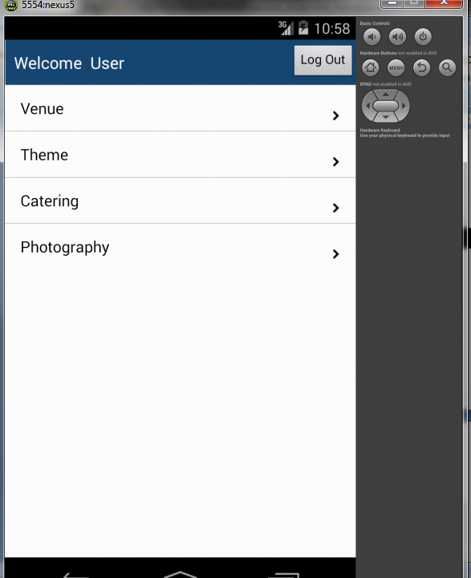

**Catering:**

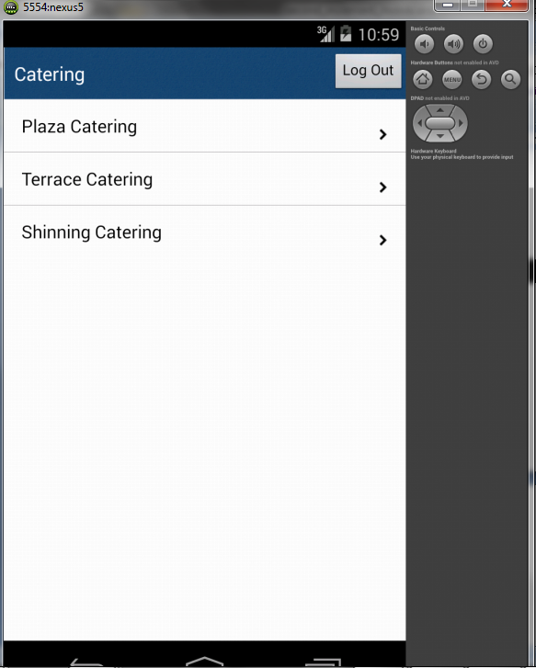

**Plaza Catering Contact:**

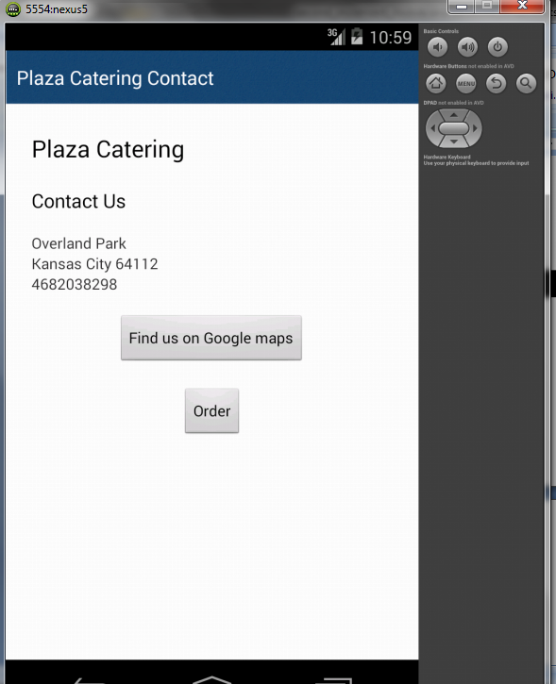

**Catering Menu:**

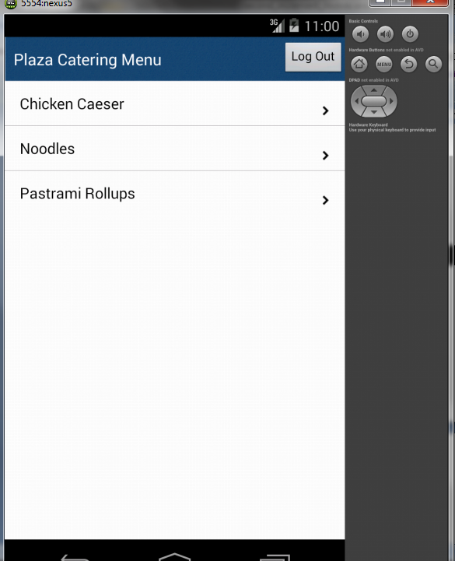

**Item Description Page:**

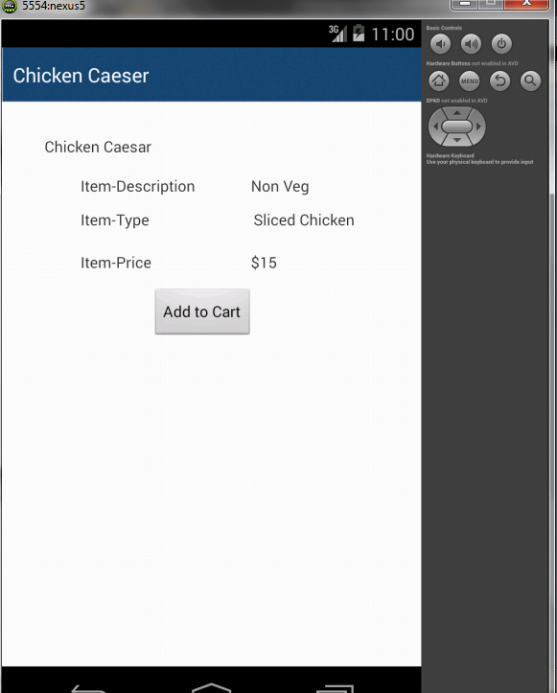

**Venue Description Page:**

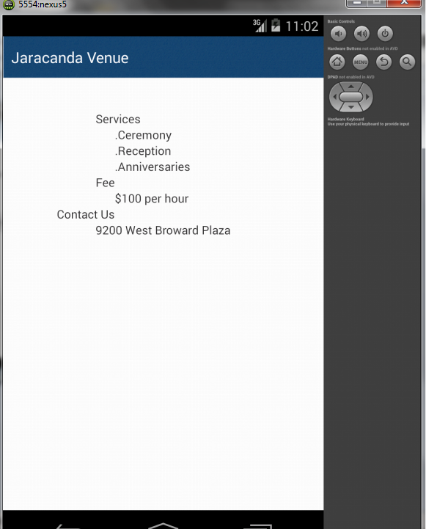

**Work Completed As Part Of 2nd Increment:**

We implemented the web services in second increment and linked it to database.

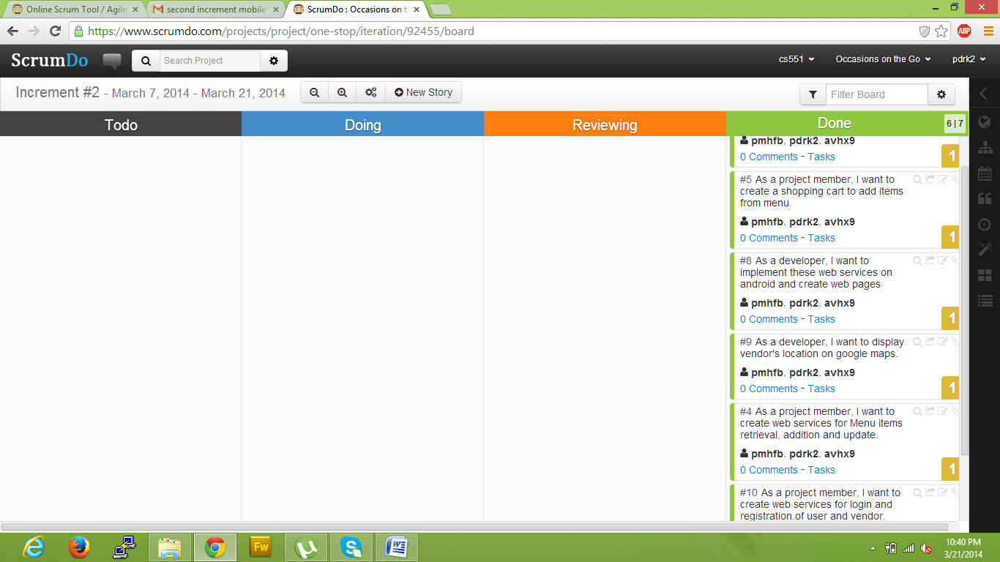

**Responsibilities:**

|  |  |  |  |
| --- | --- | --- | --- |
| **Sl.No** | **Task** | **Person involved** | **Estimated Time** |
| 1. | Created web services for login and registration of user and vendor. | Prathyusha  Anudeep  Poojitha | 8 hours |
| 2. | Created web services for Menu items retrieval, addition and update. | Prathyusha  Anudeep  Poojitha | 6 hours |
| 3. | Display of vendor’s location on Google map | Prathyusha  Anudeep  Poojitha | 2 hours |
| 4. | To implement web pages on android. | Prathyusha  Anudeep  Poojitha | 6 hours |
| 5. | Implemented shopping cart page | Prathyusha  Anudeep  Poojitha | 5 hours |
| 6. | Testing web services using Nunit testing | Prathyusha  Anudeep  Poojitha | 2 hours |
| 7. | Documentation work | Prathyusha  Anudeep  Poojitha | 2 hours |

**Work to be completed in 3rd increment:**

**Responsibilities:**

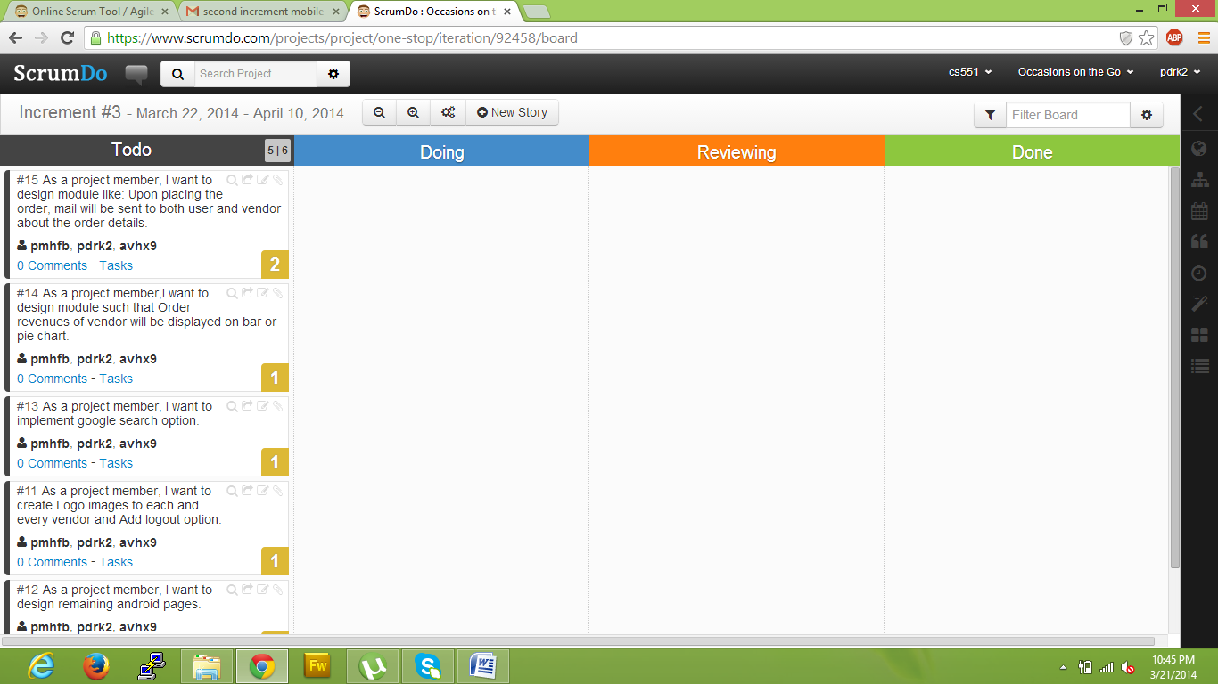

|  |  |  |
| --- | --- | --- |
| **Sl.No** | **Task** | **Person involved** |
| 1. | Upon placing the order, mail will be sent to both user and vendor about the order details. | Prathyusha  Anudeep |
| 2. | Order revenues of vendor will be displayed on bar or pie chart | Prathyusha  Anudeep  Poojitha |
| 3. | Implementing Google search engine option | Poojitha |
| 4. | Further enhancements to second increment will be implemented. | Prathyusha  Poojitha  Anudeep |
| 5. | Logo images to be inserted to each and every vendor. | Poojitha |
| 6. | Android web pages will be designed | Prathyusha |
| 7. | Testing | Anudeep |
| 8. | Documentation | Prathyusha  Anudeep  Poojitha |